4th September 2013

YOKOHAMA Tyre-equipped Car Wins 12-hour Malaysian Endurance Race for 3rd Straight Year

Tokyo – The Yokohama Rubber Co., Ltd., announced today that a car equipped with its global flagship brand “ADVAN” racing tyre won the overall championship at the 12-hour Malaysia Merdeka Endurance Race 2013 (MMER 2013) held during August 29–31. This marks the third straight year that the race has been won by a car equipped with YOKOHAMA tyres. On a course known for its extremely high road surface temperature, the YOKOHAMA tyres’ superior wear resistance limited grip loss over the long race, thereby making a big contribution to the victory.

The winning No. 7 car was a “Clearwater Racing” Ferrari 458 Italia GT3 driven by Mok Weng Sun, Craig Baird, and Hiroshi Hamaguchi. In the preliminary race, the YOKOHAMA-equipped Mercedes-Benz SLS AMG GT3 that won MMER in 2011 and 2012 came in first, with the runner-up spots taken by other YOKOHAMA-equipped cars. In the final, the YOKOHAMA-equipped No. 007 Aston Martin Vantage V8 GT3 and the No. 1 and No. 28 cars, both Mercedes-Benz SLS AMG GT3s, set the pace in the early stages but those cars soon fell down the leader board. The race then became a three-way contest between the No. 7 car, the No.3 car, also a Ferrari 458, and the No. 23 Lamborghini LP560-4. The No. 3 car led for most of the night, but the No. 7 car took the lead shortly after dawn, built a big lead and took the chequered flag after completing a record 323 laps, beating the last years’ record.

After the race, winning team driver Hiroshi Hamaguchi said, “The machine had great fuel efficiency and ran trouble-free. We installed soft tyres for the night race, and they worked great. I felt very little grip loss even after running for 40 minutes.”

The Malaysia Merdeka Endurance Race has been held each summer since 2000 as part of the celebrations commemorating Malaysia’s Independence Day on August 31. The race has drawn greater international attention each year and since 2012 has been open only to full-fledged racing cars, such as those meeting FIA GT3 standards. Participants include racing teams and drivers active in the world’s top-class endurance races. This year’s race included 13 cars, mostly FIA GT3-class, equipped with YOKOHAMA tyres.
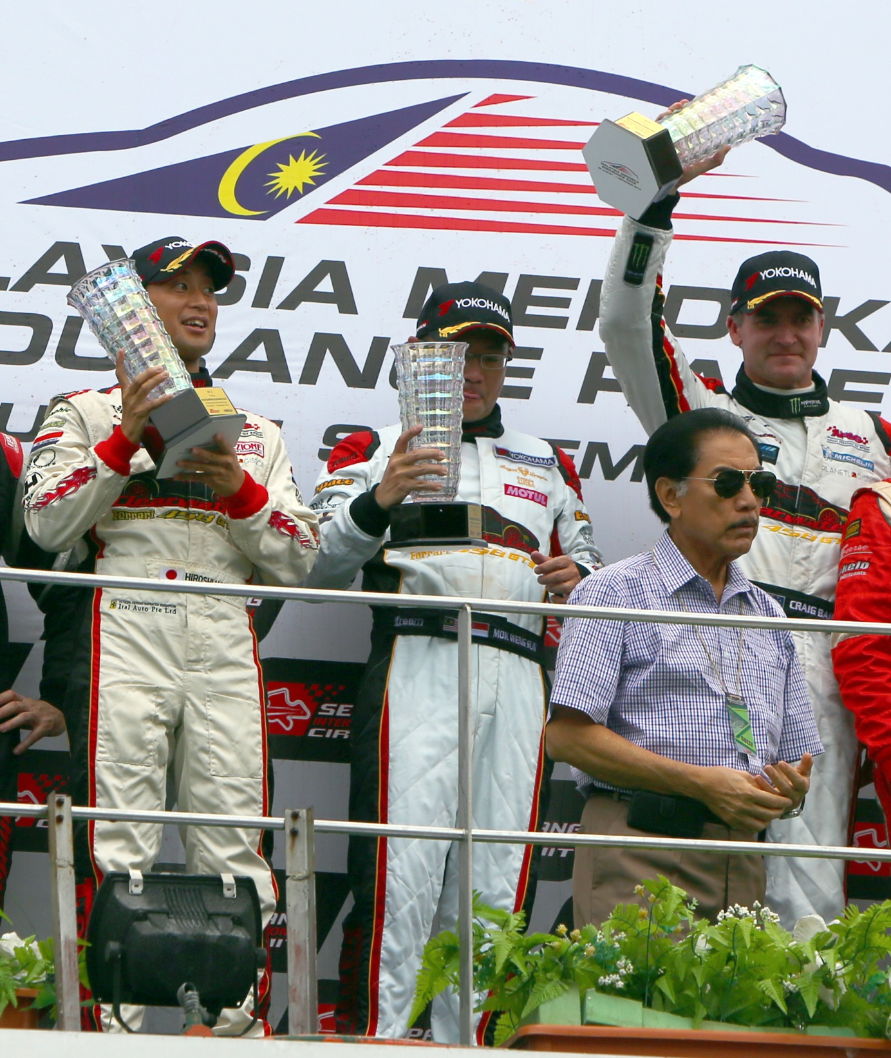
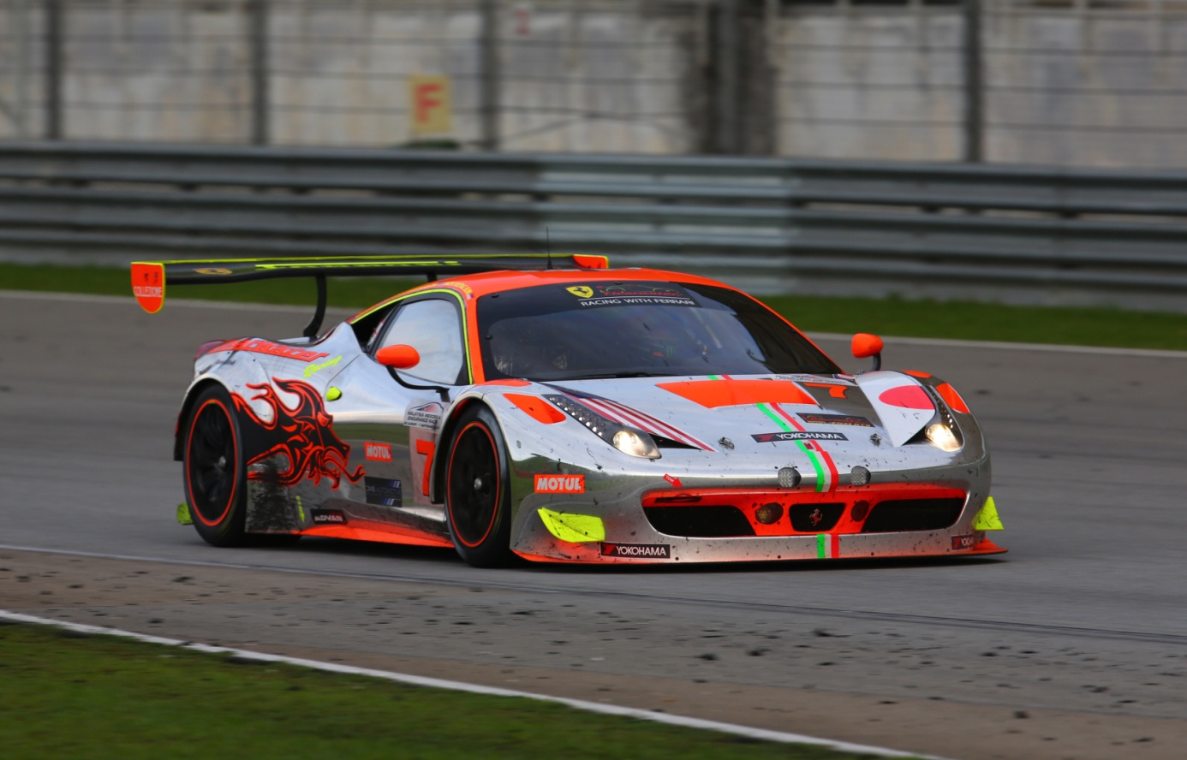
(left) Overall winner at MMER 2013: (right) Team drivers (left to right) Hiroshi
YOKOHAMA-equipped No. 7 Ferrari 458 Italia GT3. Hamaguchi, Mok Weng Sun, Craig Baird
with championship trophies.

